Que 1) Plot a histogram,

10, 13, 18, 22, 27, 32, 38, 40, 45, 51, 56, 57, 88, 90, 92, 94, 99

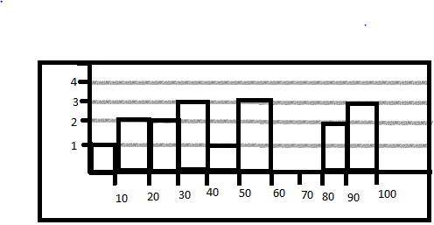

Que 2) In a quant test of the CAT Exam, the population standard deviation is known to be 100. A sample of 25 tests taken has a mean of 520. Construct an 80% CI about the mean.

σ =100 n=25 x-bar=520 C.I=80%

α=1-0.80=0.20

σ given so ztest

zα/2=z0.20/2=z0.10 ~ 1-0.10=0.9 ztable ~ 1.29

Lower Fence=x-bar - zα/2(σ/ √n)

=520-1.29\*(100/ √25)

=494.2

Higher Fence=x-bar + zα/2(σ/ √n)

=520+1.29\*(100/ √25)

=545.8

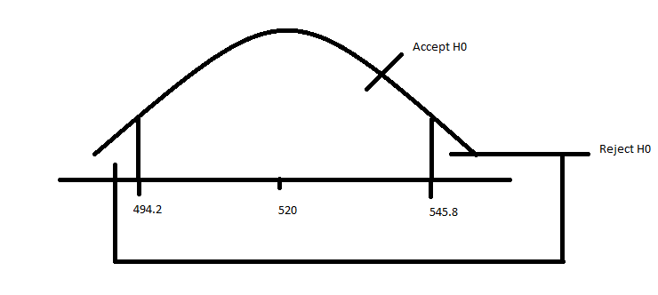

Que 3) A car believes that the percentage of citizens in city ABC that owns a vehicle is 60% or less. A sales manager disagrees with this. He conducted a hypothesis testing surveying 250 residents & found that 170 residents responded yes to owning a vehicle.

1. State the null & alternate hypothesis.
2. At a 10% significance level, is there enough evidence to support the idea that vehicle owner in ABC city is 60% or less.

H0: N<=60

H1: N>60

N=250

X=170

α=0.10

CI=0.90

P^=x/n=170/250=0.68

P0=0.6

Q0=1-p0=1-0.6=0.4

1-0.10=0.9~1.29

Z-test:

(P^-p0)/√(p0q0/n)

(0.68-0.6)/ √(0.6\*0.4/250)

2.58

2.58>1.29 Reject H0

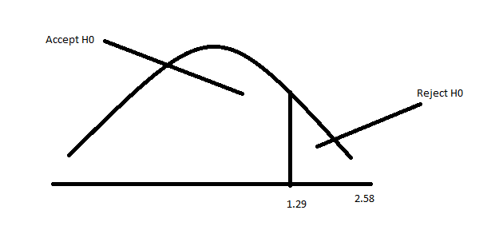

Que 4) What is the value of the 99 percentile?

2,2,3,4,5,5,5,6,7,8,8,8,8,8,9,9,10,11,11,12

Value=(percentile/100)\*n

=99/100\*20

=19.8~Index

Decimal~ (19th + 20th )/2

=(11+12)/2=11.5

Que 5) In left & right-skewed data, what is the relationship between mean, median & mode?

Draw the graph to represent the same.

